**Jason Phua Kai Xiang** **PE03**

**Johnson Ng Chong Sheng**

1. **Objectives**

This project aims to build an RPA app that automatically sends the absentees, weekly attendance rates and overall attendance rate of a class to the teacher, saving the teacher’s time.

1. **Functionalities**

**Google Forms Data Retrieval (Johnson)**

-Able to download csv data from google forms for attendance automatically

**Data Scraping Class List (Johnson)**

-Able to datascrape and filter classlist from brightspace automatically.

**Attendance Rate Calculation (Jason)**

-Able to calculate attendance rates per week, and average attendance rate across the weeks

**Data Comparison (Jason)**

-The RPA app compares the csv file data with the classlist, to filter out students who did not submit the attendance forms and marks them as “Absentees”

**Auto-email (Jason)**

-After the Attendance rates and Absentees are written to a “Attendance.xlsx” file, it will be emailed automatically to the teacher of the class.

1. **Limitations**

* very limited to the data provided, will need revisions if provided with different data
* unable to email to absent students
* workflow could be more efficient
* correpath for attachment of excel file to email requires manual input
* data input for google form responses was manually inserted

1. **Conclusion**

Overall, a more comprehensive dataset would have allowed us to do more for this project, such as auto-emailing students who did not submit, work with more weeks and classes.

The project has a lot of areas to work on, such as being able to work with any dataset with minor adjustments, work on parts where it can be

1. **Appendix**

Flowchart

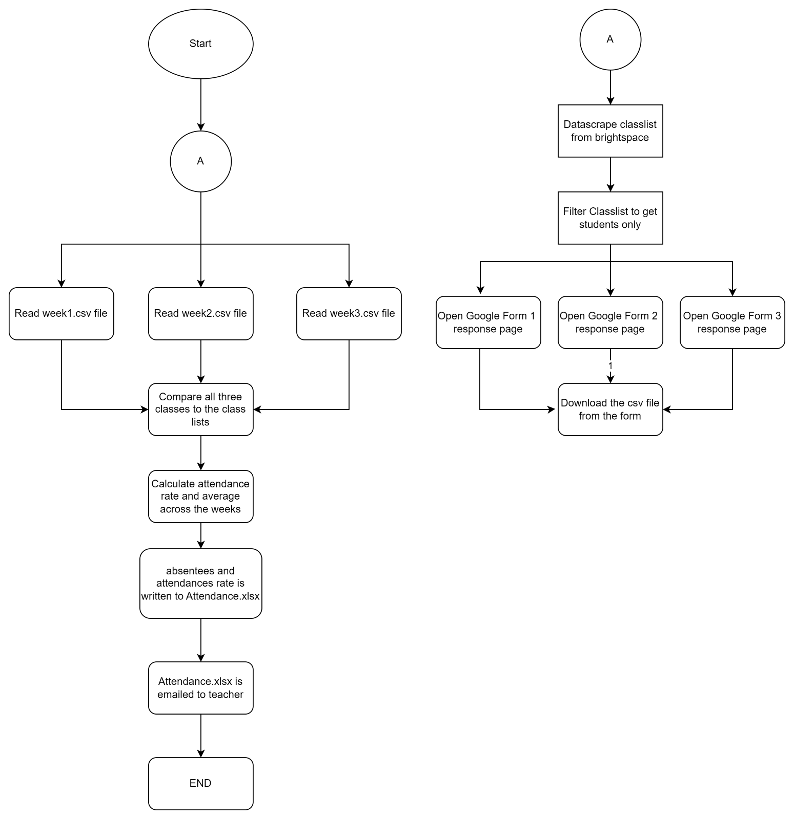

Flowchart design

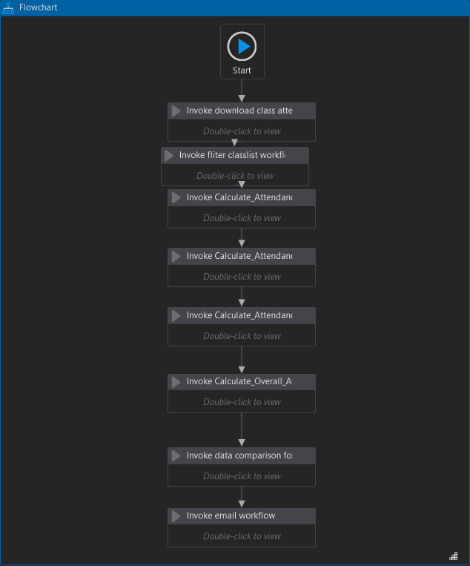

Data scraping and auto-download flowchart

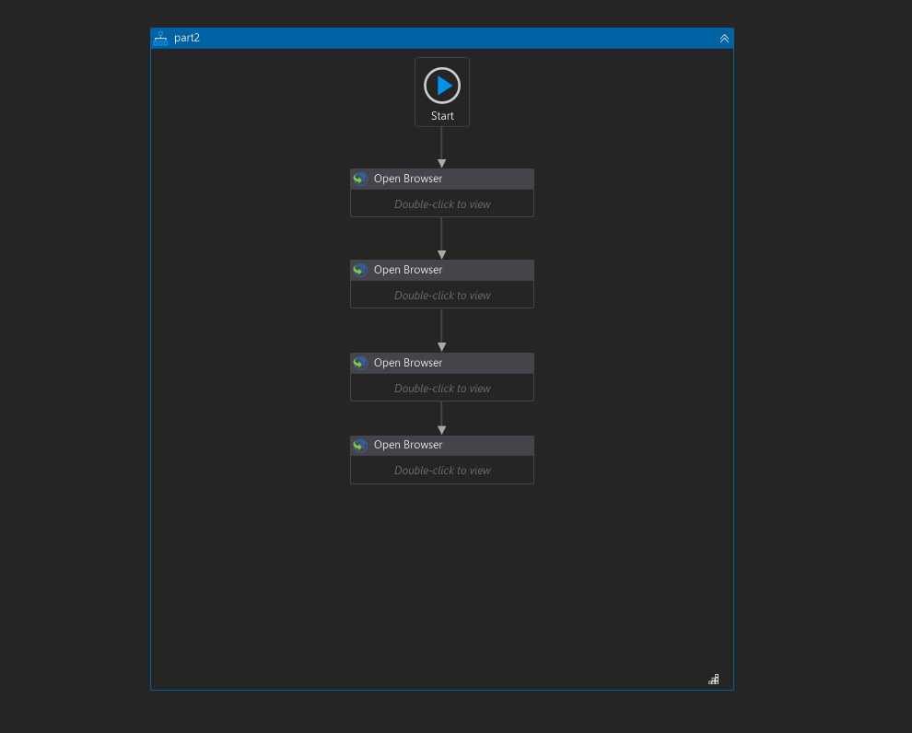

week 1 download

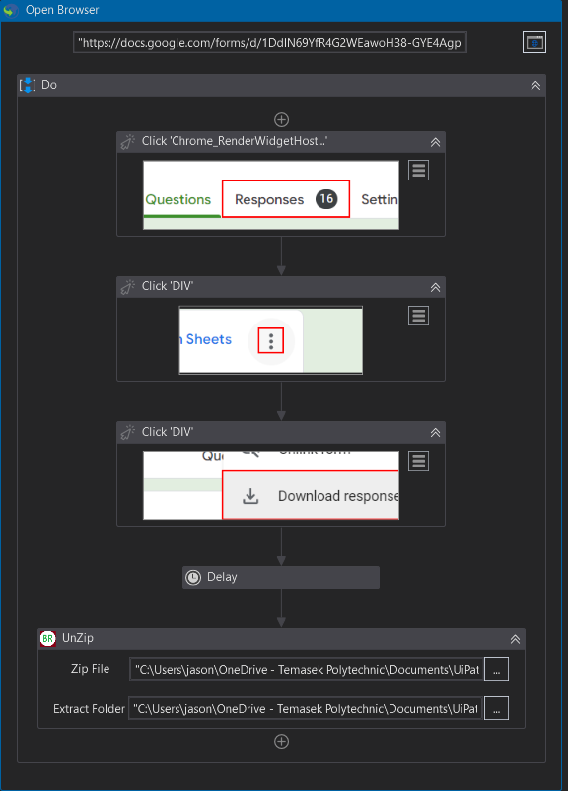

Week 2 download

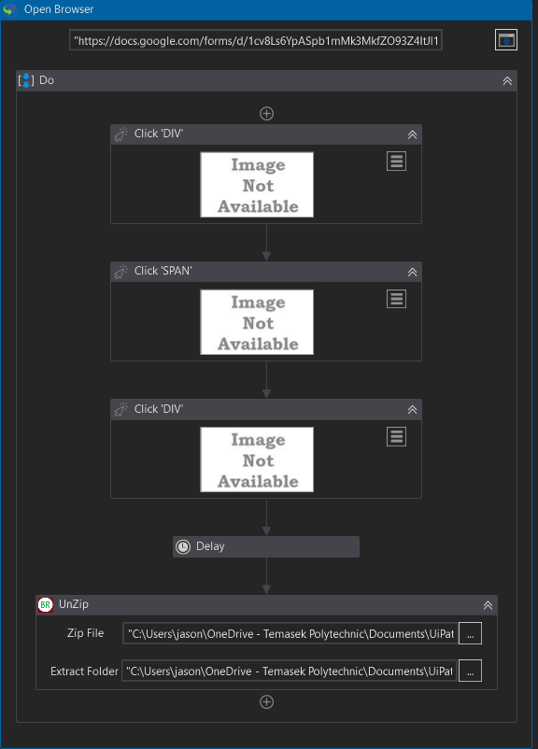

Week 3 download

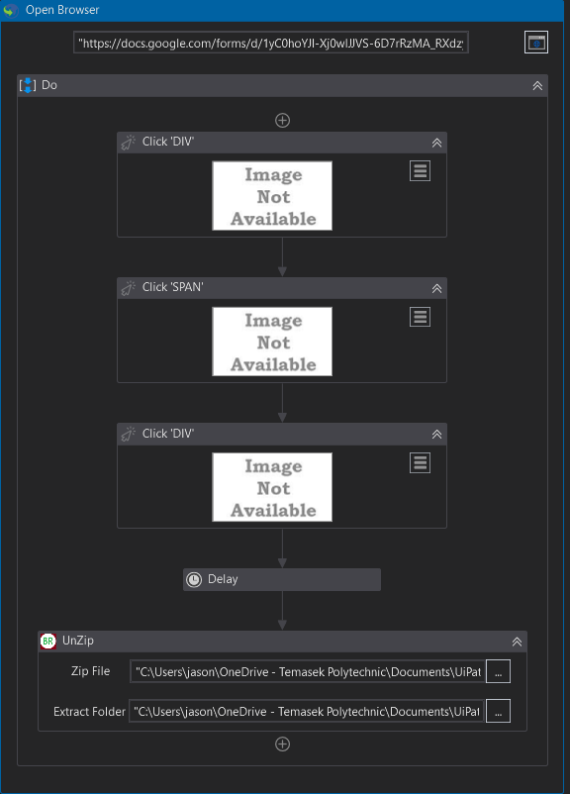

Datascrape classlist

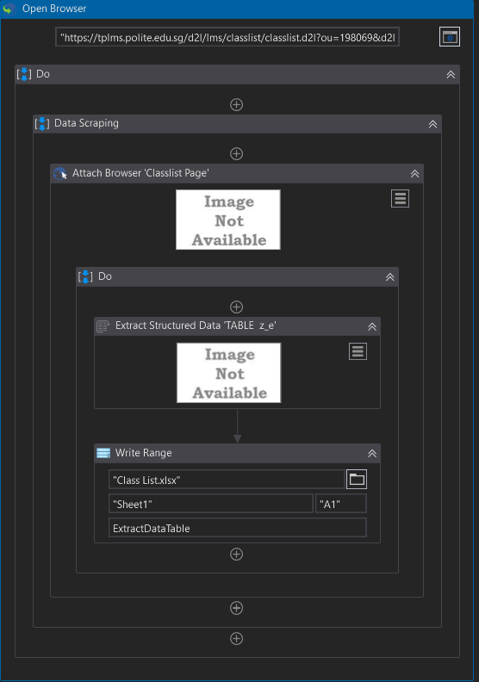

Filter class list

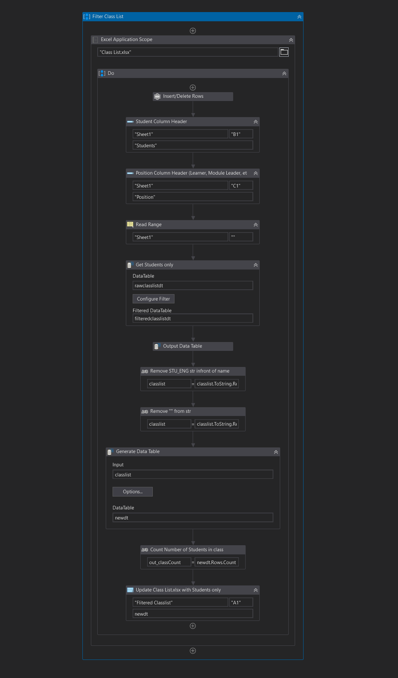

Calculate attendance week 1

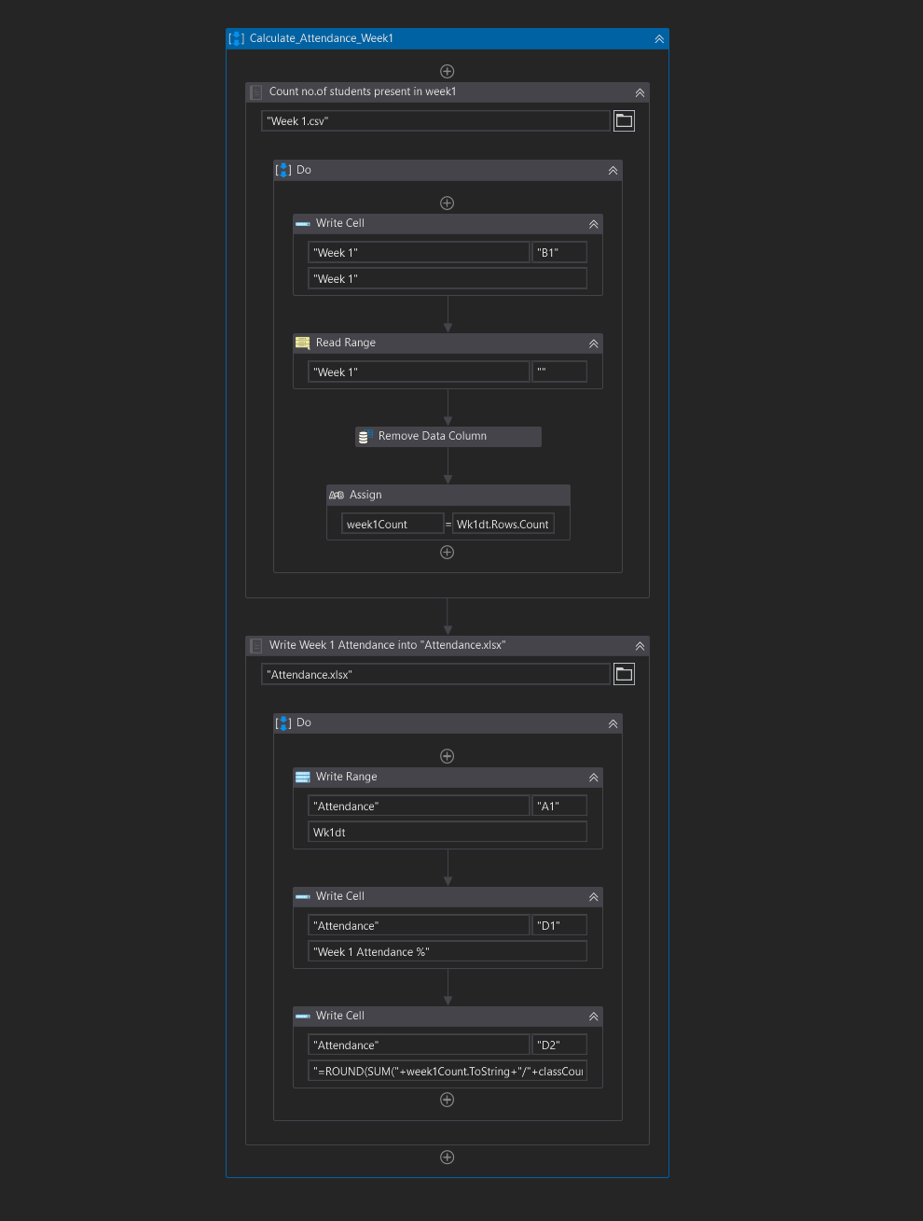

Calculate attendance week 2

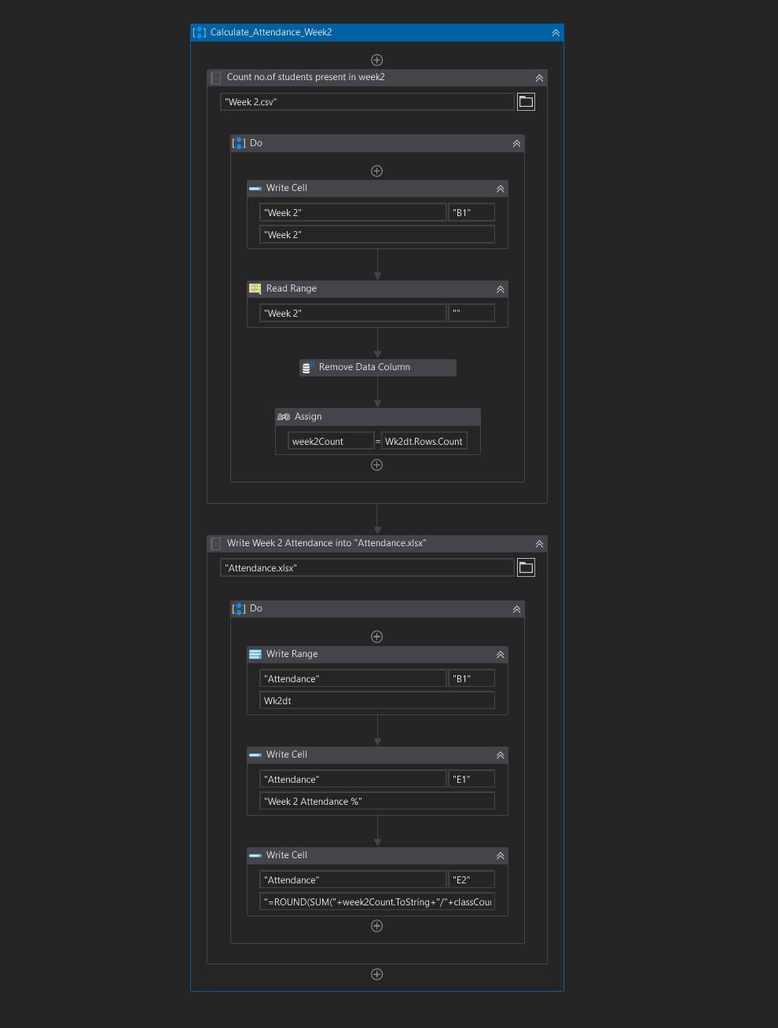

Calculate attendance week 3

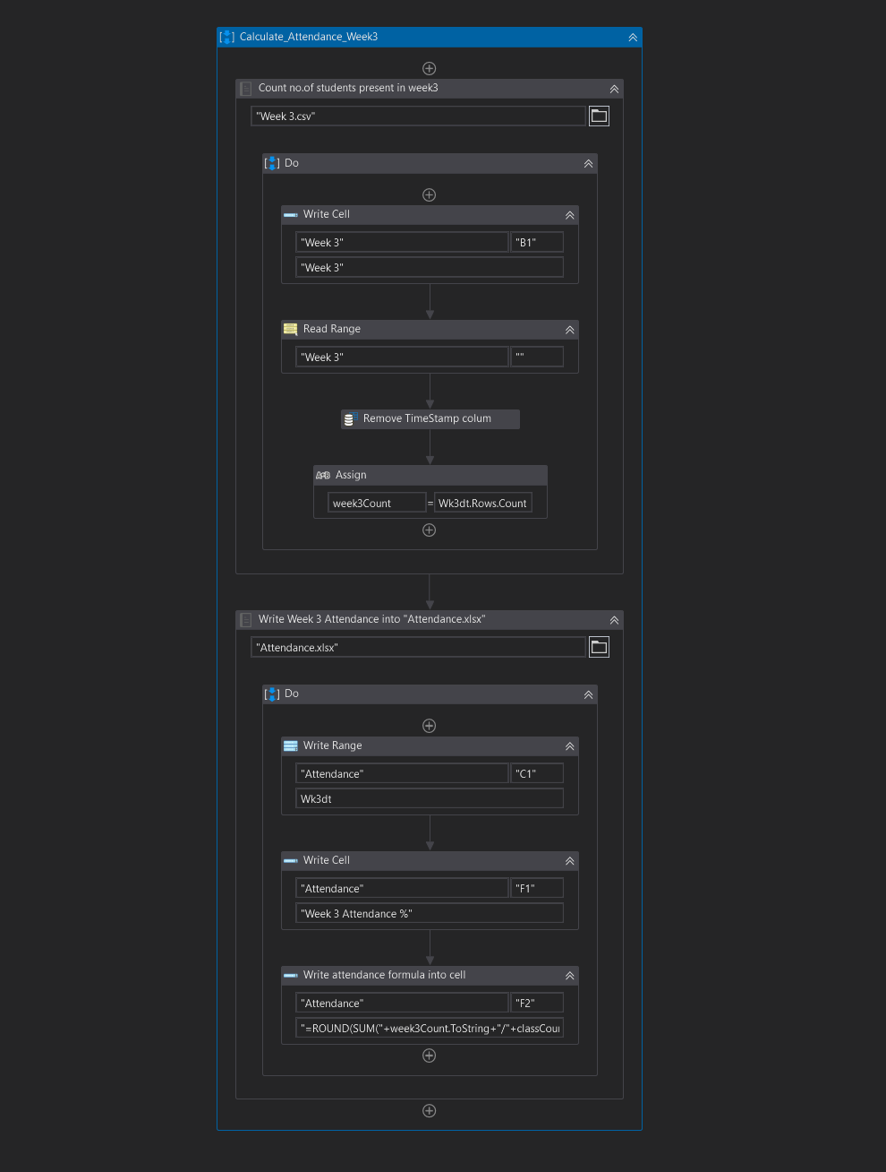

Calculate overall attendance

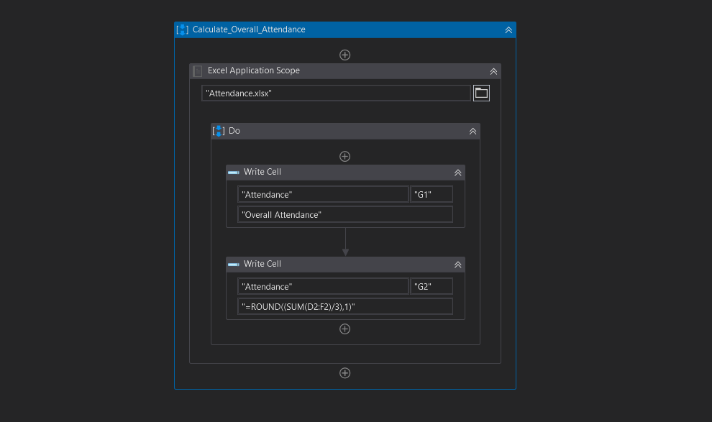

Data comparison

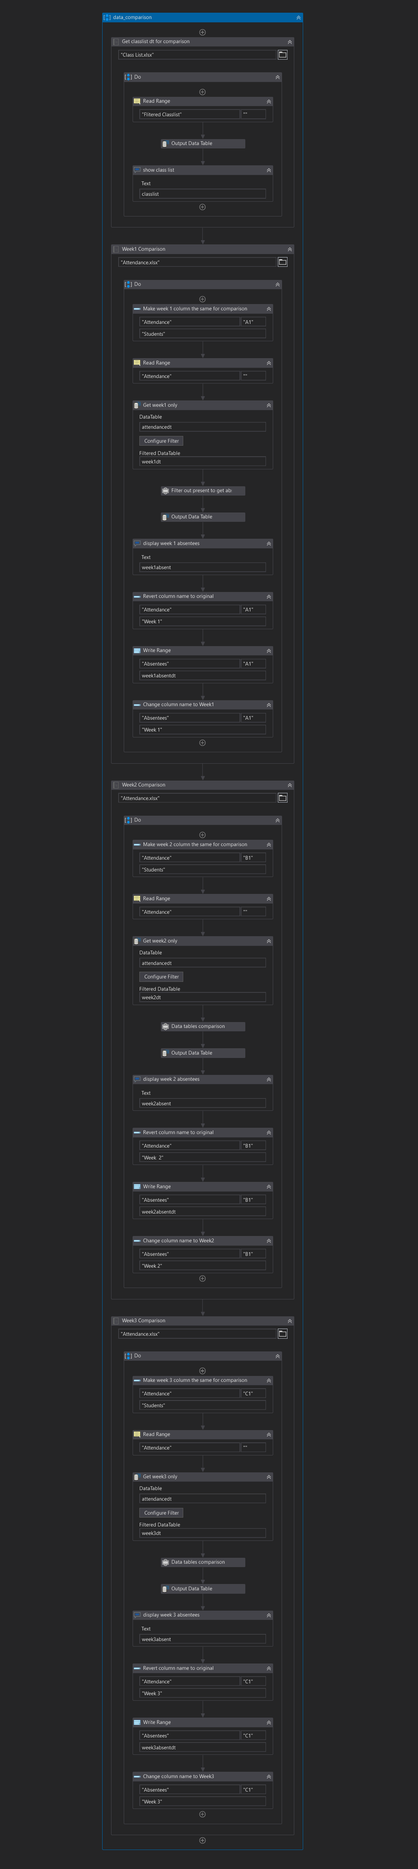

Email

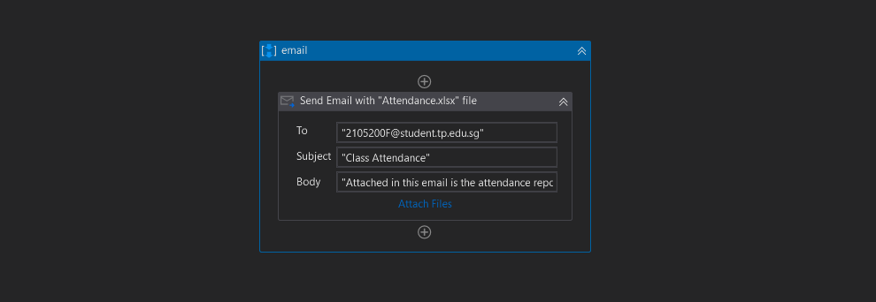

Output:

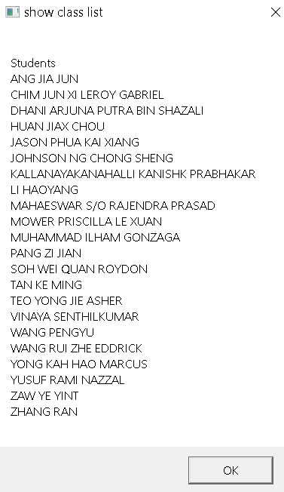

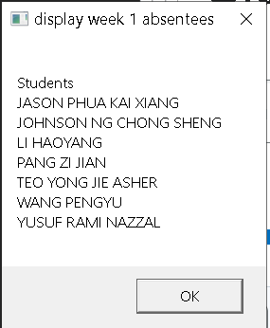

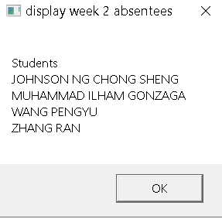

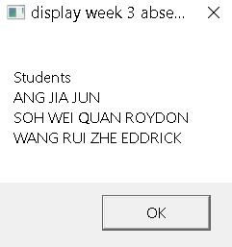

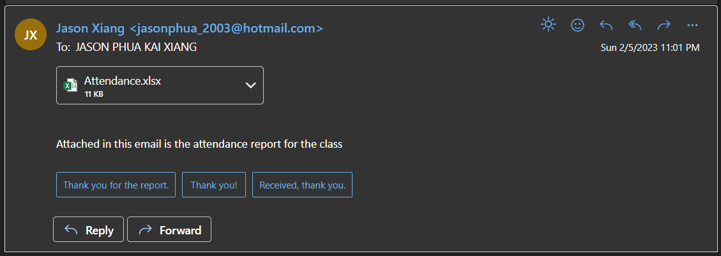  
**Classlist data**

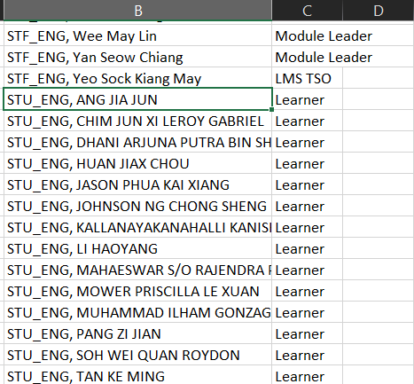  
**Week 1 Attendance Form data** (15 responses)

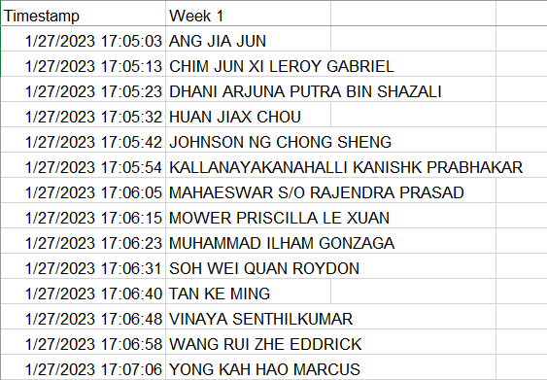  
**Week 2 Attendance Form** (18 responses)

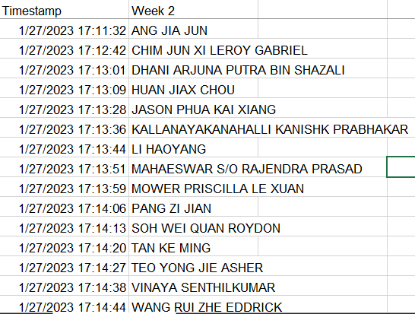  
**Week 3 Attendance Form** (19 responses)

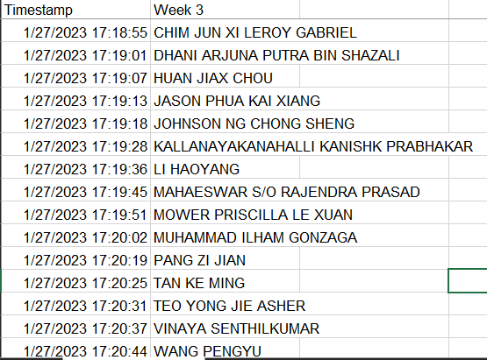  
**Appended Attendance Forms with Weekly and Overall Attendances Rates**

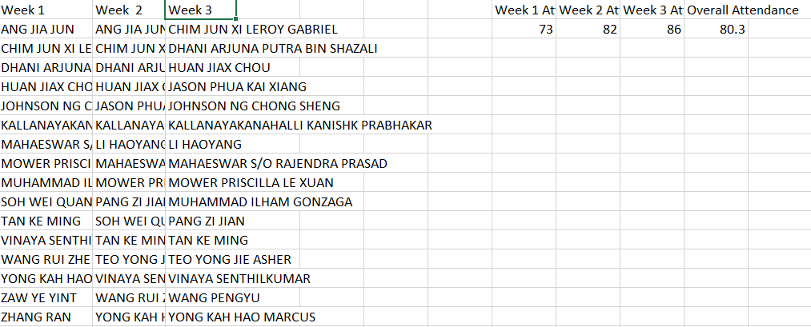  
 **Week 1, 2 and 3 Absentees**

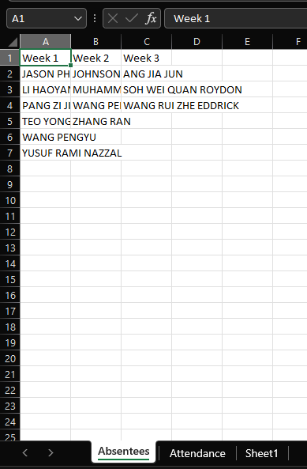

Steps/File path changes required for project to work:

For each of the google forms auto-download, the unzip file path has to be changed

Google download settings change to project file path, uncheck “Ask where to save each file before downloading”

In the email workflow, email should be changed to own email, attachment file path should be changed to Attendance.xlsx in project file path (varies on computer).

**Extra Packages used:**

UiPathTeam.DatatablesComparison.Activities v2.0.0

BalaReva.ZipUnzip.Activities v2020.4.3